***Sketch 1:***

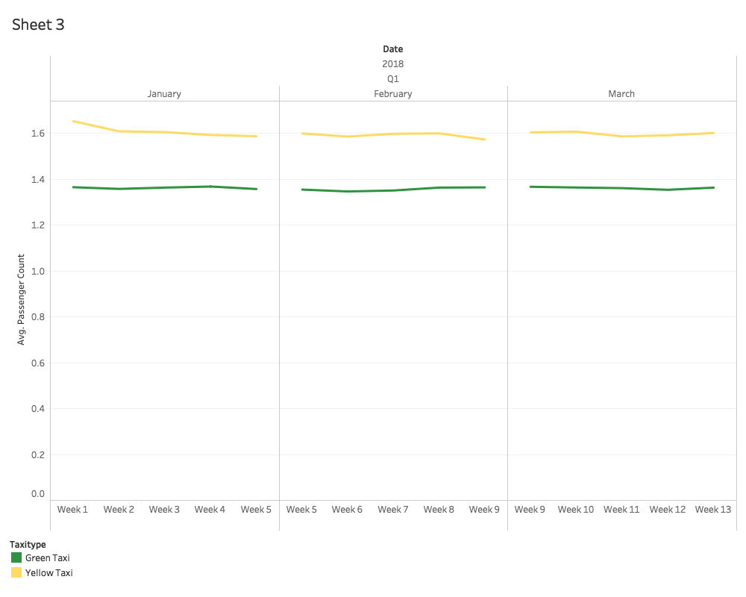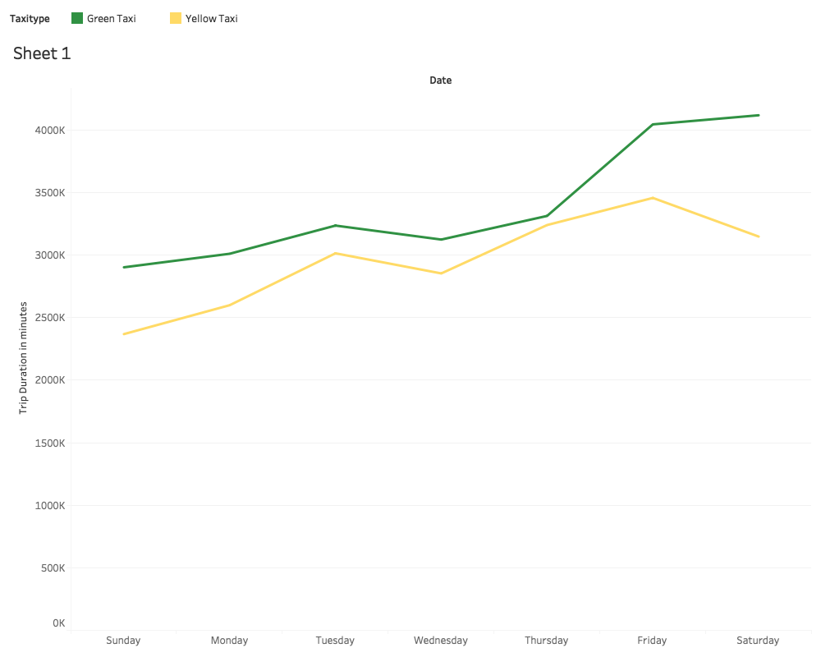

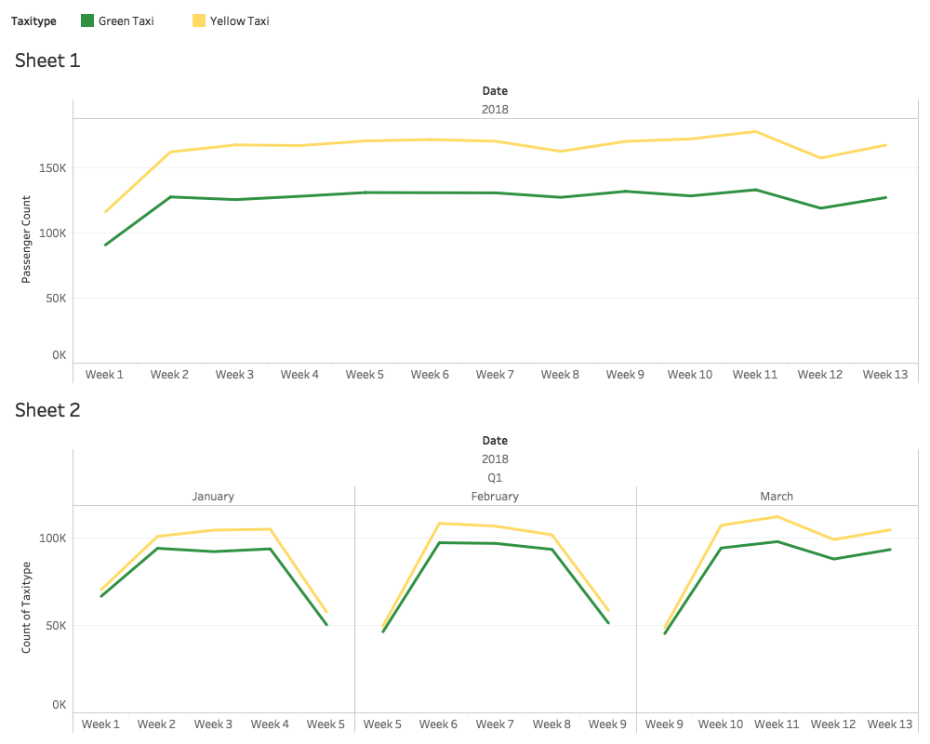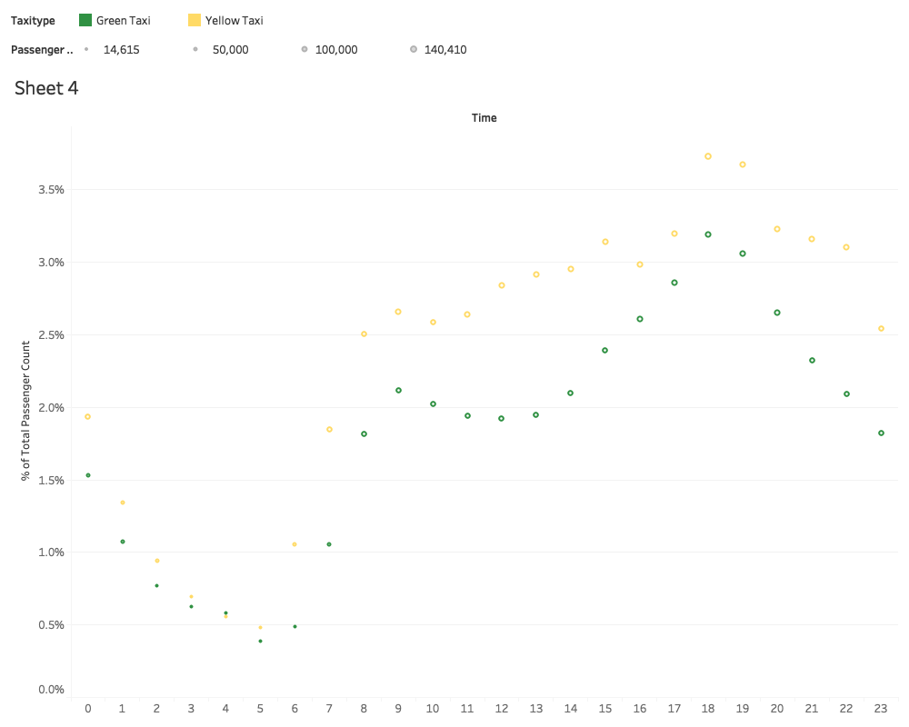

***Sketch 2:***

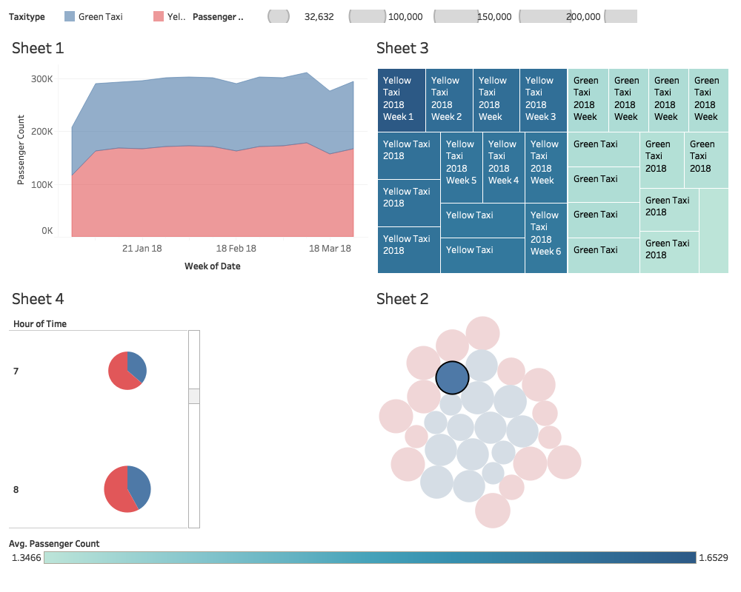

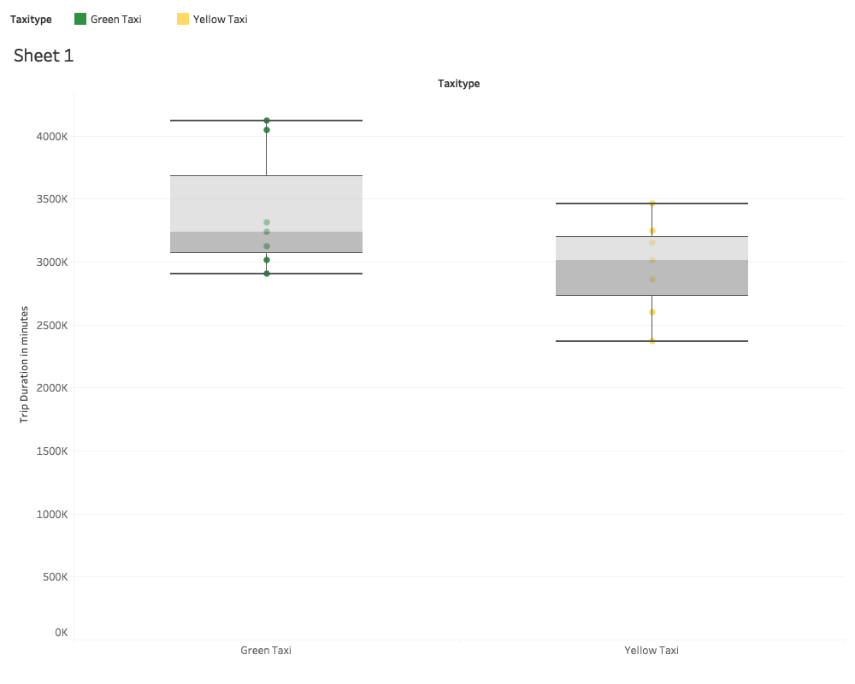

***Justification:***

The 1st sketch contains sensible plots like dot plot and line charts that are really good in this scenario. Also, the color choice of the legends is very smart (green for green taxi and yellow for yellow taxi). The analysis of the data is easy in the 1st sketch.

On the other hand, the graphs in sketch 2 are not intuitive. It has pie charts, packed bubbles, ineffective area charts which are neither sensible nor easy to visualize for a common person. The scales of measure in some cases are confounding and not easy to find. As far as comparison of the green and yellow taxi goes the sketch does not give a clear idea about that either.

After evaluating the overall quality of the sketches we choose the 1st Sketch.